Exit Getting Started Overview

To begin, we need to access our exit virtual machine (VM):

1. Access Exit

Enter <https://labs.exitcertified.com> in your URL

Sign in with your assigned credentials

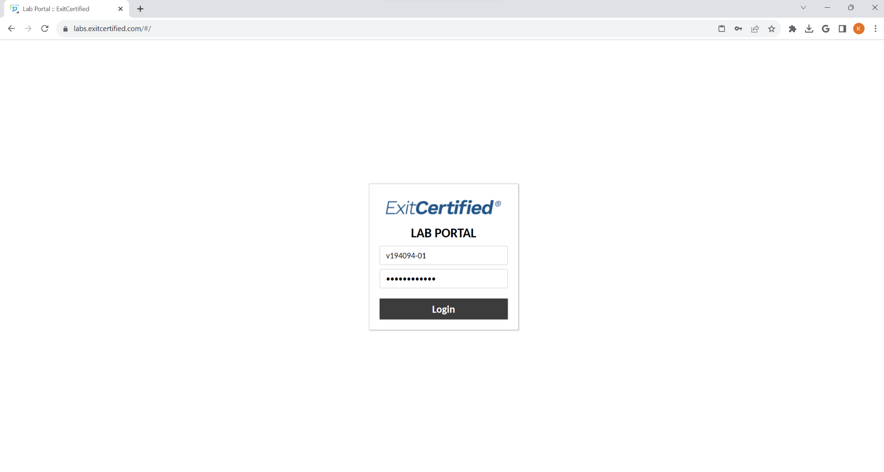

Select “View Console”

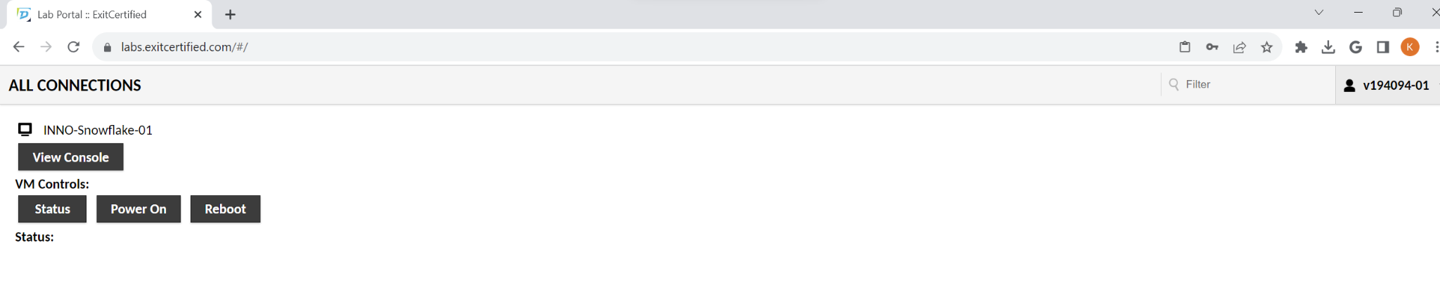

You will then have access to your virtual machine. Through this machine, you will be able to access Snowflake, AWS and other resources.

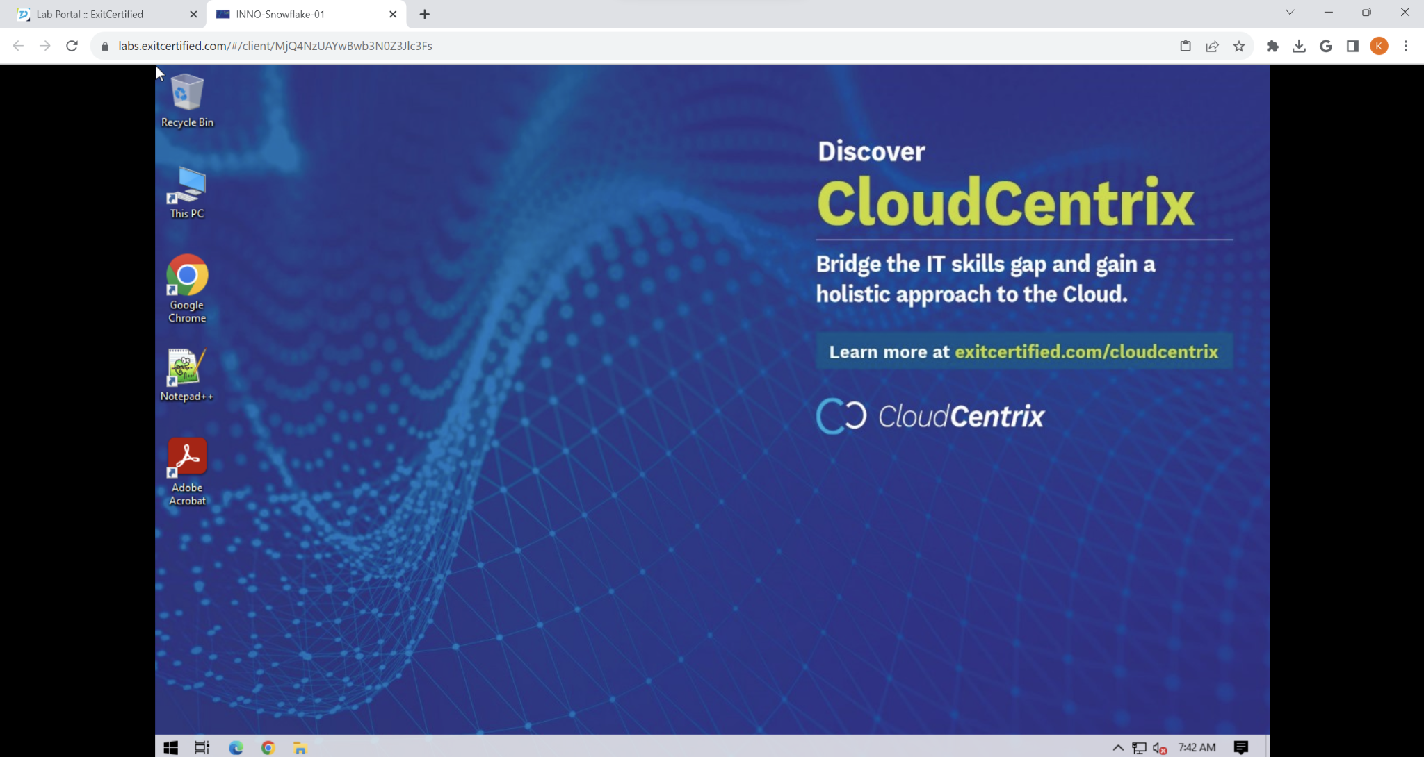

1. Sign-up for Snowflake

Use the Sign-up for Snowflake module to access Snowflake.

<https://www.dropbox.com/scl/fo/l0ni0qvixqu8jc75ygv6m/h/experiments/00-Snowflake-Getting-Started.pdf?rlkey=xcuxcb2cruu0hfqlgowynnc2d&dl=0>

1. Access AWS

Enter <https://signin.aws.amazon.com/> in your VM web browser and select signin

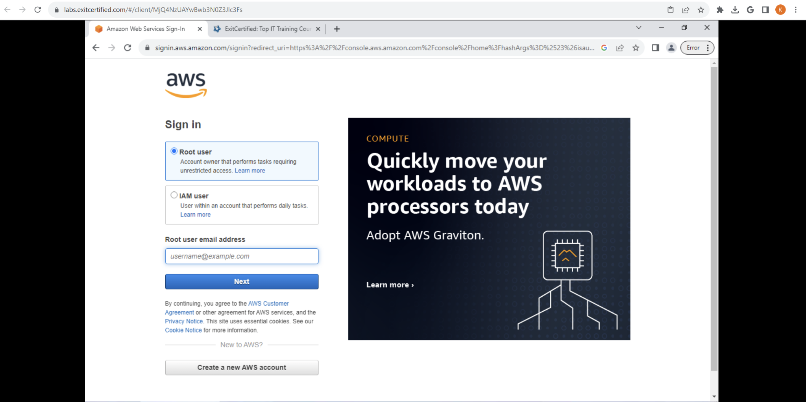

Enter your assigned AWS credentials. If you do not have one, you can create a new account with a personal email address.

Set your region to the region selected for your Snowflake instance (critical)

1. Create Cloud9 Environment

Cloud9 is a cloud-based IDE offered by AWS. This tool can work with numerous programming languages and connect to a myriad of resources

To access, search for Cloud9 under AWS services and select

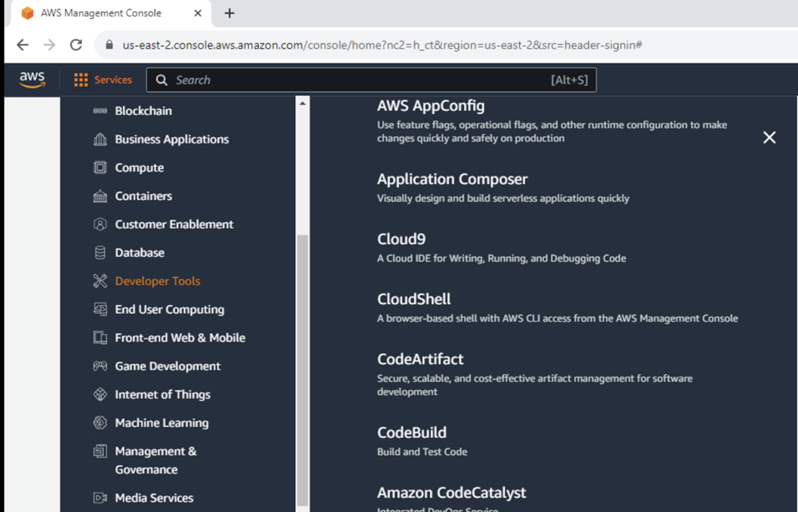

To create a new environment, select “Create New Environment”

Complete the form:

* Enter a name
* Use New EC2 Instance
* Set OS to Ubuntu
* Keep all other default values

Select create

Open Cloud9 instance after initialized by AWS

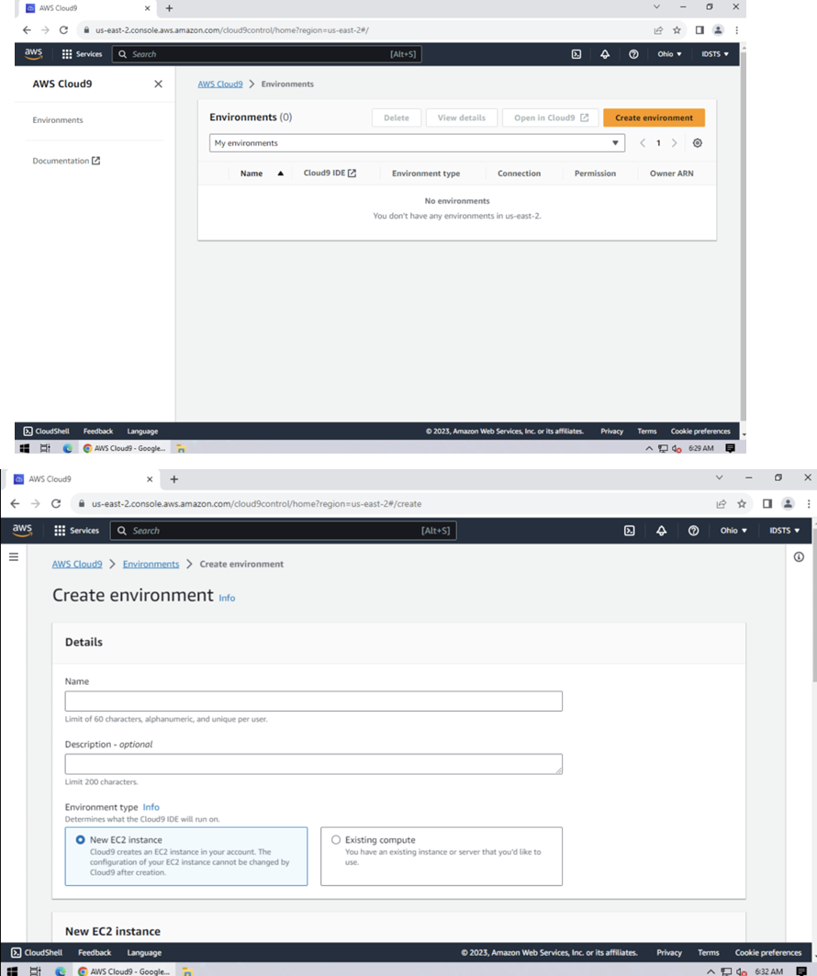

You will see the Cloud9 IDE open in the browser. You can leverage multiple programming languages, including SQL, Python, Java and more in Cloud9

1. Clone and connect GitHub Repository to Cloud9

Enter <https://github.com/> in your VM web browser

Log into your github account or create a new one

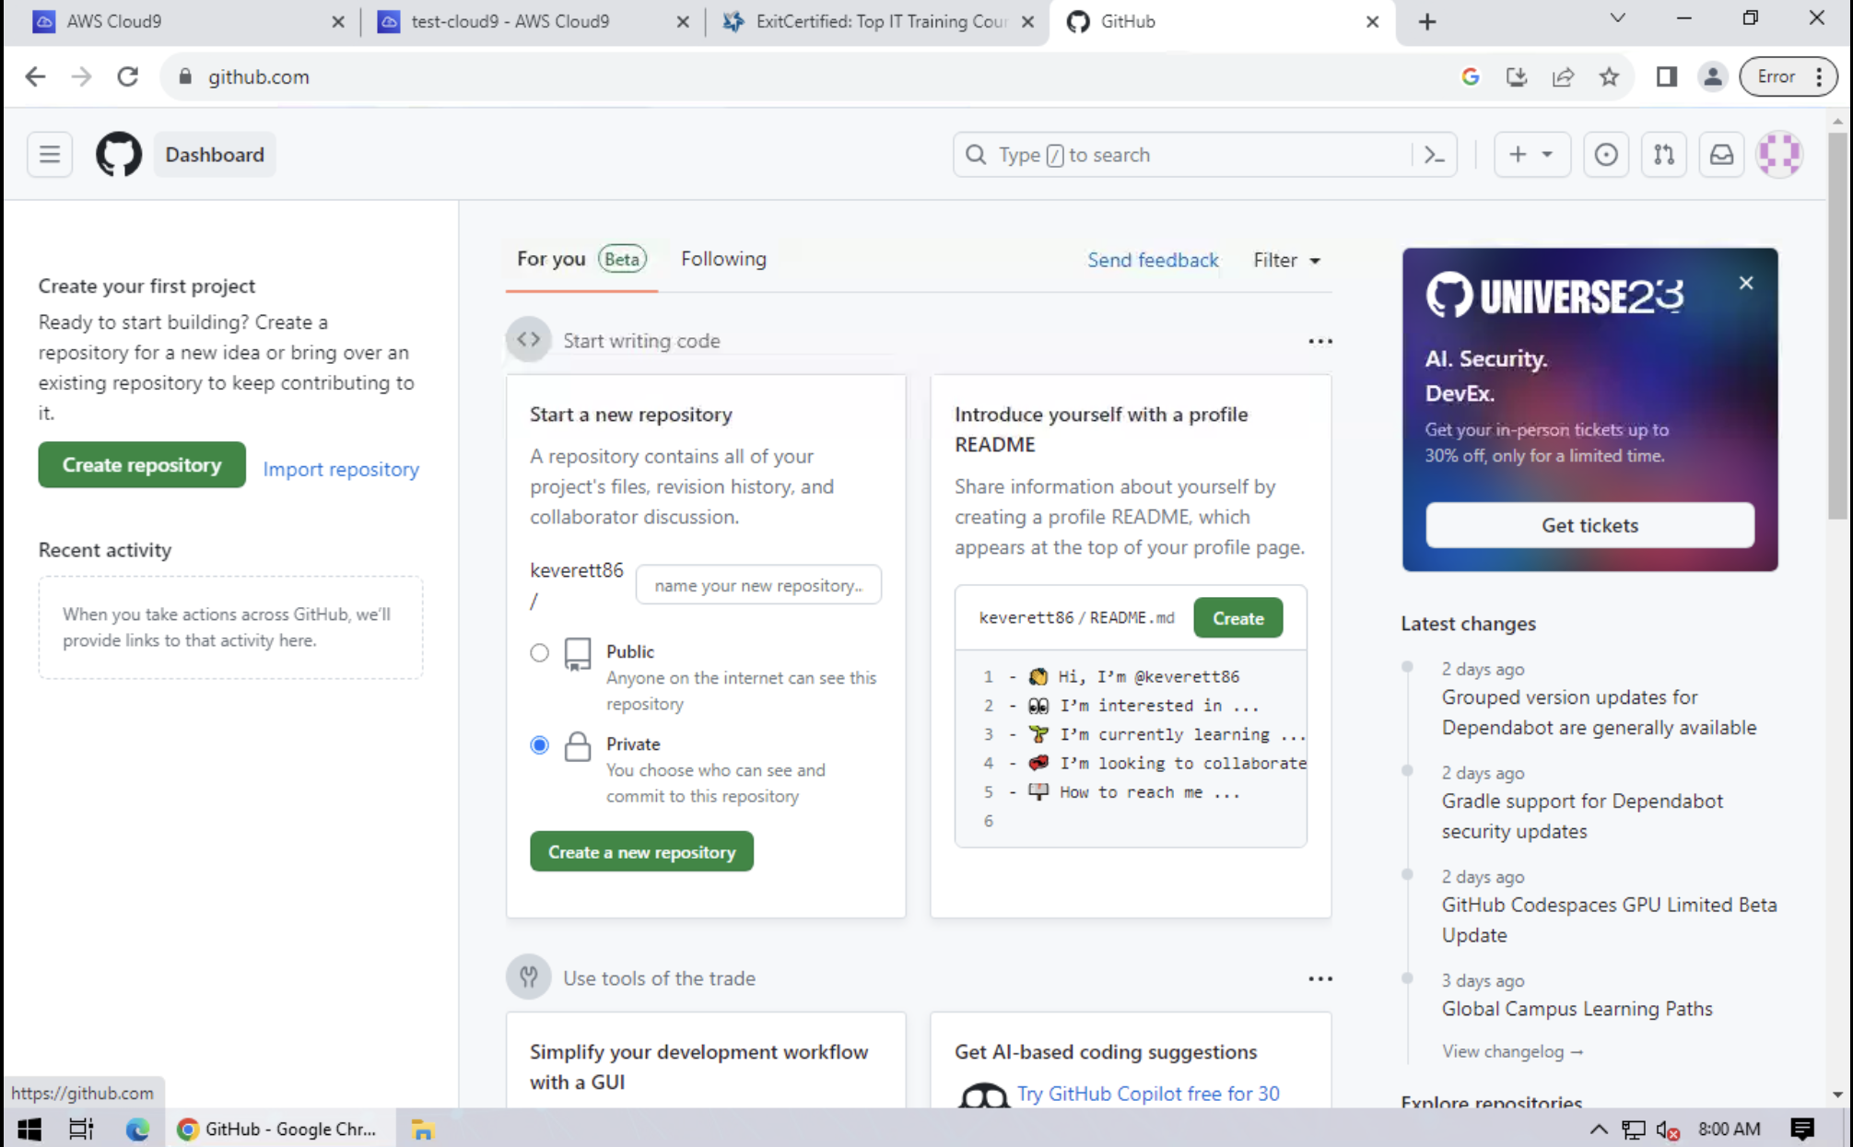

Search for the following repo: devidsts/snowflake-course

Make a copy of the repo for your own usage by creating a fork

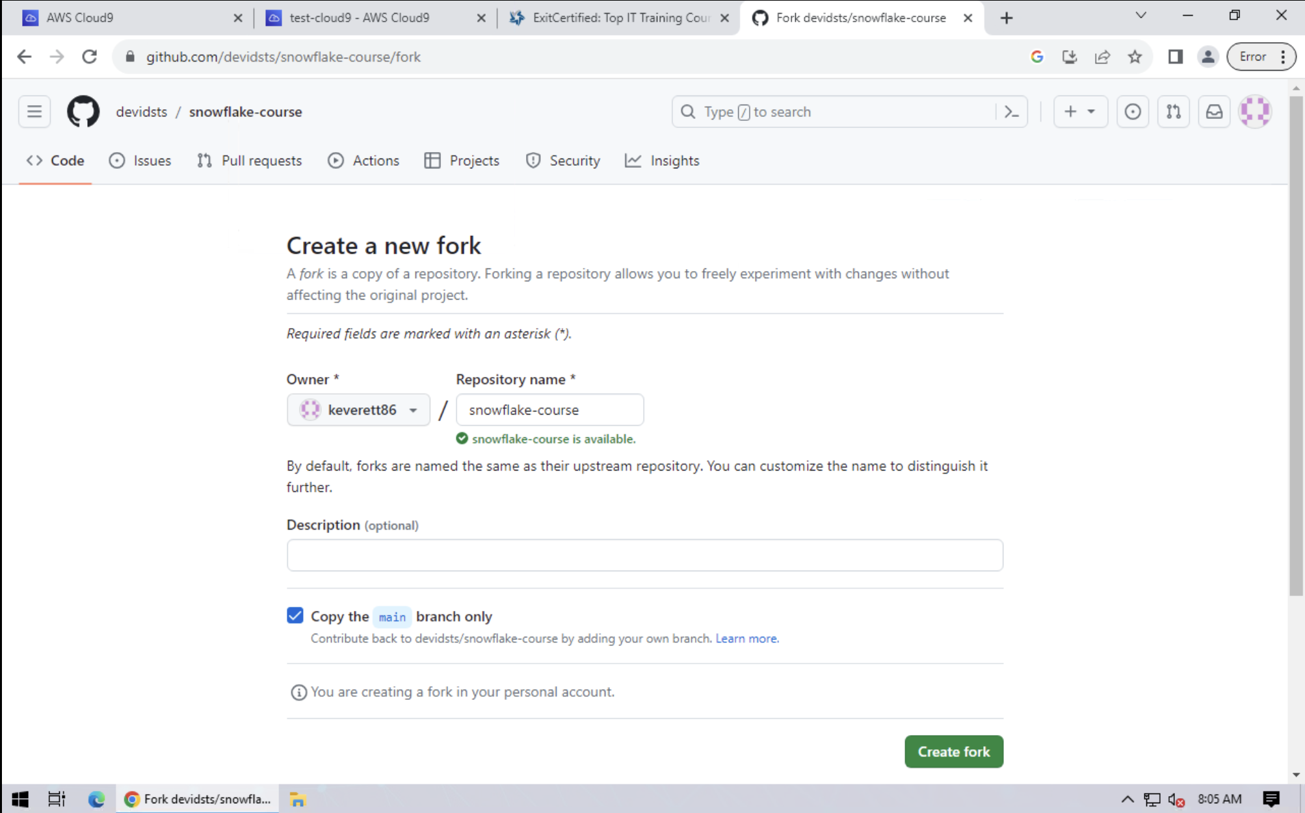

This will get you access to all the course material.

Enter the following commands in the terminal to connect GitHub to Cloud9:

In Cloud9, select the source control button and “Clone Repository”

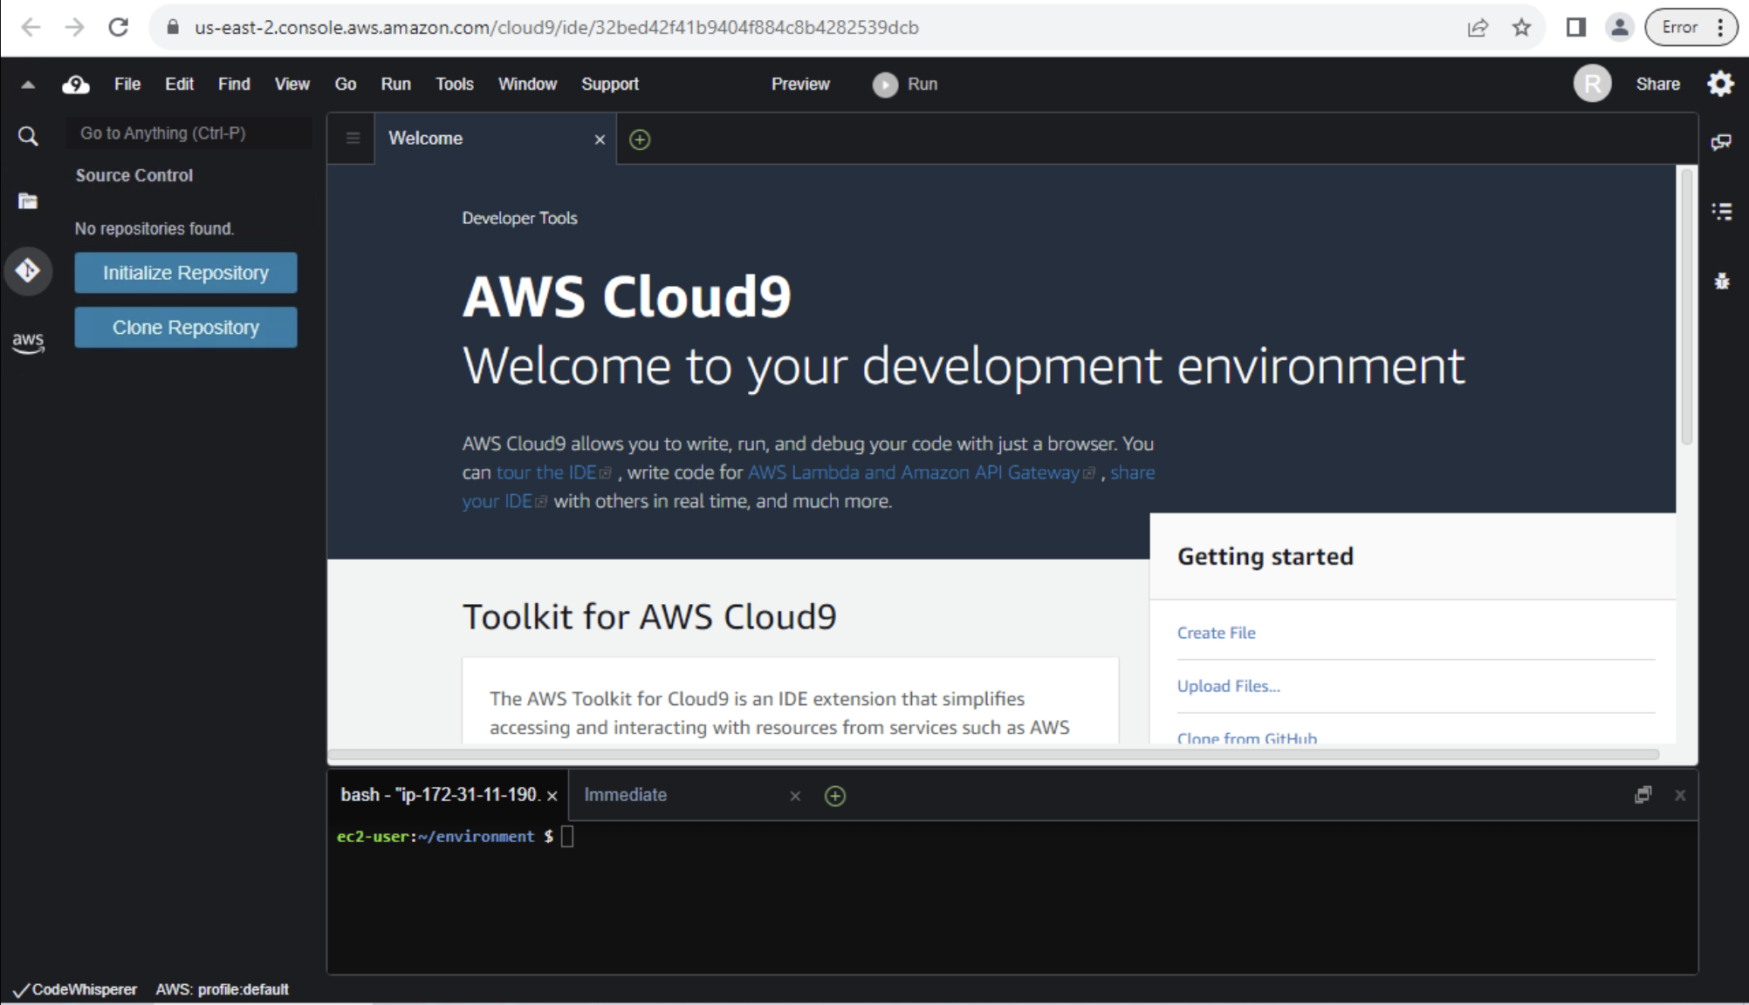

Get the clone link from GitHub and connect Cloud9

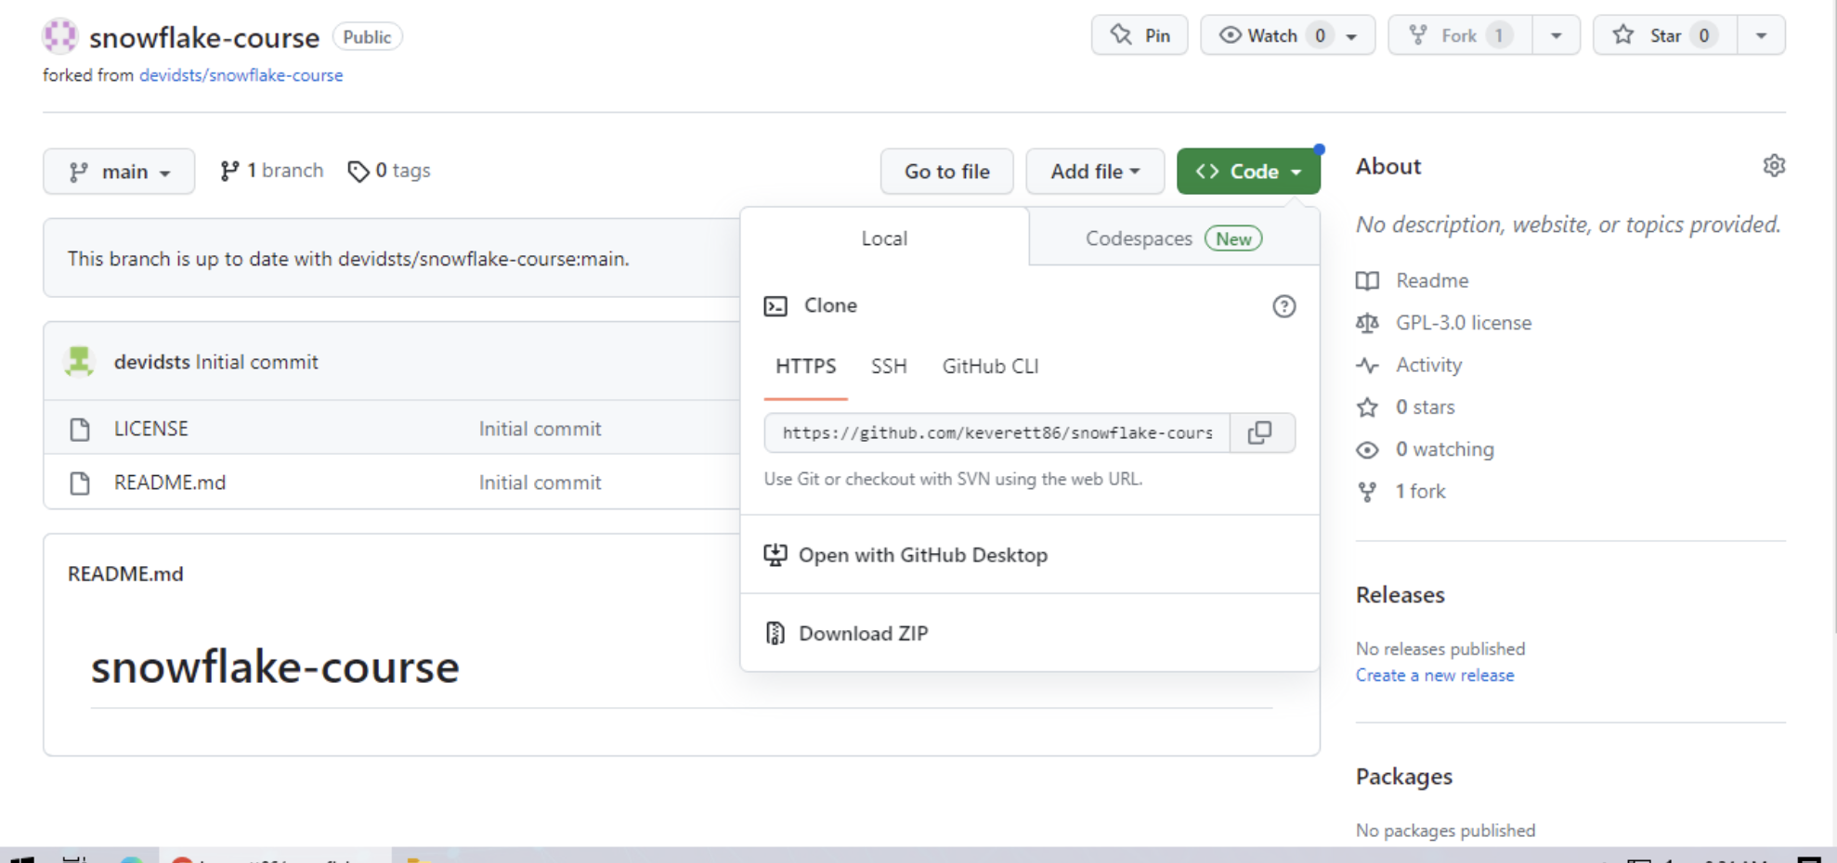

Enter the link into Cloud9 and the repository will now be available in Cloud9

